Chapter 19, Problem 79.

Use PSpice to determine the z parameters of the circuit in Fig.19.125. Take ω = 2 rad/s.

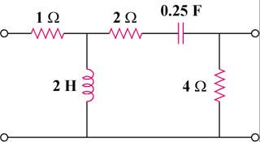

Figure 19.125
For Prob. 19.79.

